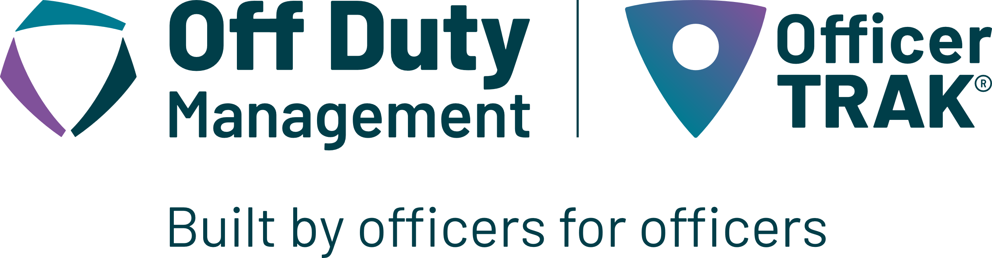
In order to efficiently respond to requests and manage the employment of off-duty police officers, The Buffalo County Sheriff’s Office has partnered with Off Duty Management to provide services related to hiring off-duty officers effective September 27, 2021.
You may request to hire off-duty police officers through the Off Duty Management web-based service, OfficerTRAK®, or calling the number below.
Off Duty Management provides the following to the customer:
- Online access to information through the OfficerTRAK® software including:
  - Job-status
  - Officer attendance
  - Media files
  - Post orders and instructions
  - Past and future shift information
- Full liability coverage for the customer, the agency, and the officer
- 24/7 customer service through their dedicated agency phone number
- Dedicated points of contact for scheduling, invoicing, and payroll.
RATES:

Shift Type | Total Billable Hourly Rate
Regular | $57.50
Supervisor | $69.00
Holiday | $69.00
Emergency | $63.25
Vehicle | $33.06
2 Hours Minimum per Request

SUPERVISOR RATE: Requests for four or more deputies require a supervisor.

HOLIDAY RATE: The holiday rate will apply to the following days:

Agency Recognized Holidays
New Year's Day | January 1
Martin Luther King Jr. Day | Third Monday in January
Presidents' Day | Third Monday in February
Memorial Day | Last Monday in May
Juneteenth | June 19
Independence Day | July 4
Labor Day | First Monday in September
Veterans Day | November 11
Thanksgiving Day | Fourth Thursday of November
Day After Thanksgiving (Also known as Black Friday) | Friday Following Thanksgiving
Christmas Eve | December 24
Christmas Day | December 25

EMERGENCY RATE: If request is received less than 72 hours prior to assignment the emergency pay rate goes into effect
Cancellation policy: Customer cancelling or reducing an assignment within 48 hours of the start of the assignment shall pay the greater of officer hours worked or the agency minimum hours plus ODM administrative fees.
YOU CAN REQUEST SERVICE BY VISITING THE OFFICERTRAK® WEBSITE LINK:

https://odm.officertrak.com/Buffalo-Co-NE-SO

OR CALL OFF DUTY MANAGEMENT 24/7 AT 1-877-636-8300

